Exercise 4: Arrange-Act-Assert (AAA) Pattern, Test Fixtures, Setup and Teardown Methods in JUnit
Scenario: You need to organize your tests using the Arrange-Act-Assert (AAA) pattern and use setup and teardown methods.
Steps:
1. Write tests using the AAA pattern.
2. Use @Before and @After annotations for setup and teardown methods.
Implementation:
Calculator.java
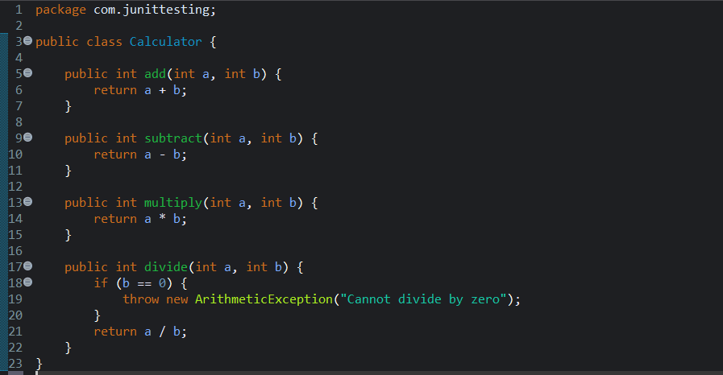
AAATest.java
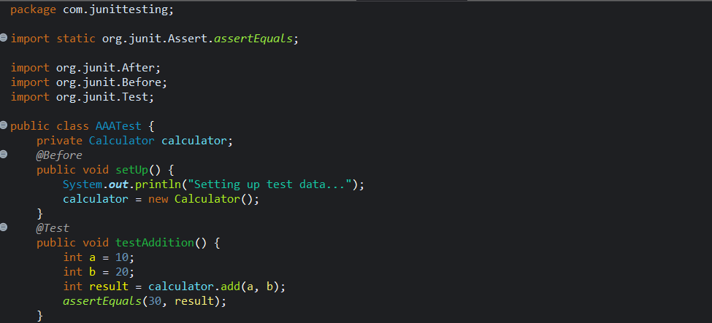

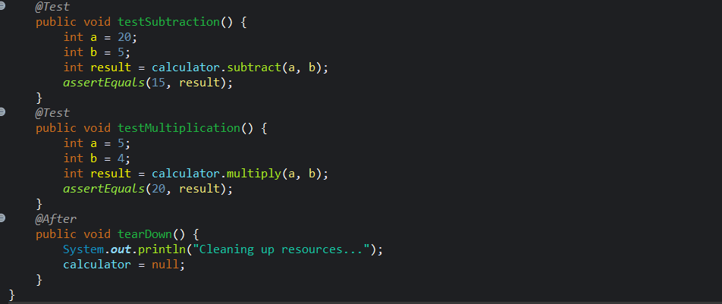

OUTPUT:

